Key Concepts and Workflow Overview
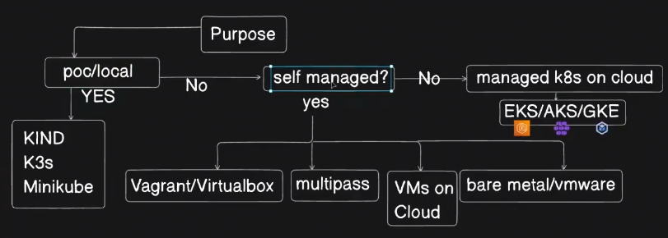
Purpose of Kubernetes Installation:
  - Local/POC/testing: Use tools like kind, minikube, or k3s for quick setups running on a single local machine (not production-grade).
  - Production/organizational use: Choose between managed Kubernetes services (EKS, AKS, GKE) or self-managed clusters on VMs or bare metal.

Cluster Setup Architecture:
  - Requires 3 VMs: 1 Control Plane (Master) node and 2 Worker nodes.
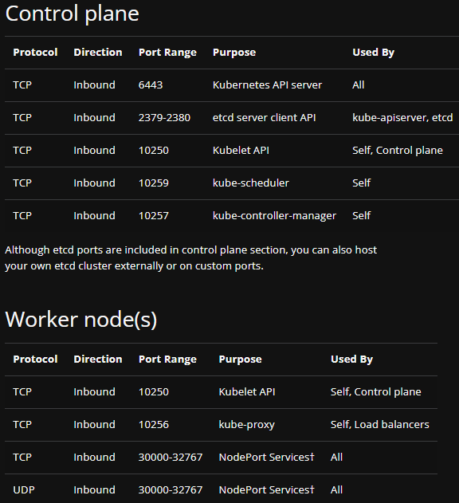
  - VMs can be on any cloud or local VM environment, but cloud-based multi-host clusters are preferred for high availability.

Networking and Security:
  - Creation of Security Groups or firewall rules to allow specific ports for Kubernetes components.
Ports to be opened:
    - SSH: Port 22 for admin access (not always documented explicitly but required).
    - High port range (30000-32767) for external services/load balancers.
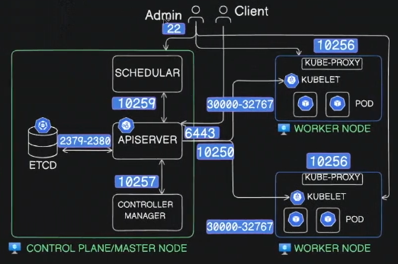
  - Restrict sensitive ports (etcd, scheduler, controller manager) to internal VPC traffic only as they dont need to be connected to anything external.
  - Etcd has 1 port for client and 1 for server.

Container Runtime Components:
  - Docker (High-Level Tooling): is the developer-facing CLI and API. It handles building images, managing networks, volumes, and orchestrating containers. It used to have its own runtime, but now delegates container execution and lifecycle operations to containerd.
    - ContainerD (runtime) - A core container runtime maintained by CNCF. A long-running daemon that manages container lifecycle and low level tasks (start, stop, pause, snapshot, image pull). Docker uses containerd under the hood to actually run containers. Exposes APIs (gRPC) for higher-level tools like Docker or Kubernetes. Delegates the actual container execution to runC. Kubernetes also uses containerd directly (via CRI – Container Runtime Interface).
    - RunC (low-level OS interface for container creation) - Implements the OCI runtime spec. Given a container bundle, it sets up namespaces, cgroups, mounts, and executes the container’s PID 1. It’s invoked by containerd whenever a container needs to be started.

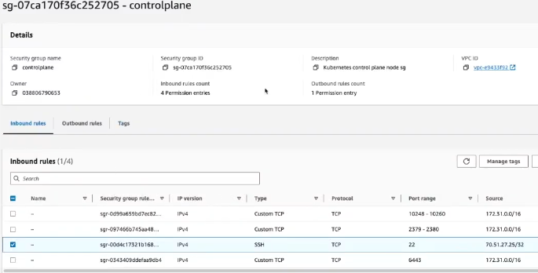
Control plane SecurityGroup – Inbound rules: “destination” is not specified in inbound rules because inbound rules define traffic coming into the instance, not where it’s going. destination is implicitly the EC2 instance (or ENI) that the security group is attached to.
Allow TCP to all control plane ports (10248-10260) on the instance from source = CIDR of VPC (172.31.0.0/16), so all traffic coming from the whole VPC CIDR to the instance:ports within the VPC.
Allow TCP to etcd ports (2379-2380) on the instance from source = CIDR of VPC (172.31.0.0/16).
Allow ssh into the instance.
Allow TCP to api server (6443) on the instance from source = CIDR of VPC (172.31.0.0/16).

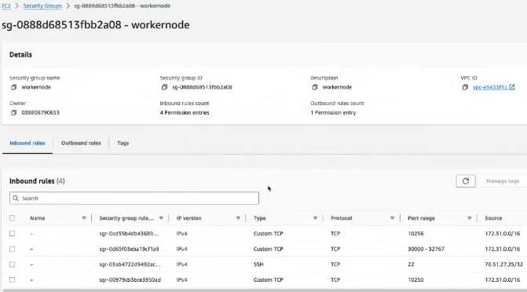
Worker Node SecurityGroup – Inbound rules:
10256 for kube-proxy, 30000-32767 for external services, 22 for ssh, 10250 for kubelet.

    - Docker → containerd → runC → Linux kernel . Docker is the user-facing interface. containerd is the orchestration engine. runC is the executor that actually spawns the container process.
Cluster Initialization Steps (common on all nodes):
  - Disable swap.
  - Update kernel parameters related to networking.
  - Install container runtime (containerd is now default; Docker deprecated since Kubernetes 1.24).
  - Install runc and CNI plugins (e.g., Calico, Cilium).
  - Install Kubernetes command-line utilities: kubeadm, kubelet, and kubectl.
- Control Plane (Master) Node:
  - Initialize control plane using kubeadm init with parameters including pod network CIDR and API server IP.
  - Use network add-ons like Calico or Cilium to enable pod networking and network policies. Flannel and Weave are not recommended (Flannel lacks network policy support; Weave is outdated).
  - Troubleshoot network plugin issues such as mismatched pod network CIDR between kubeadm init and Calico configuration.
  - Use kubeadm reset to reset the control plane if errors occur and rerun initialization with corrected parameters.
- Worker Nodes:
  - Perform the same preparatory steps (disable swap, install container runtime, CNI plugins, utilities).
  - Join the cluster by running the kubeadm join command on the worker nodes using the token generated at control plane initialization. Pass the API server address.
  - Copy the kubeconfig file from master to worker nodes to enable kubectl access.
- Verification:
  - Use kubectl get nodes and kubectl get pods -A to verify node status and pod readiness.
  - Confirm all control plane components and network pods are running and nodes are in Ready state.
- Additional Notes:
  - Used Ubuntu VMs on AWS EC2 instances (T2.medium recommended for control plane).
  - Emphasize the importance of consistent Kubernetes versions (all utilities and components at v1.30 in this case).
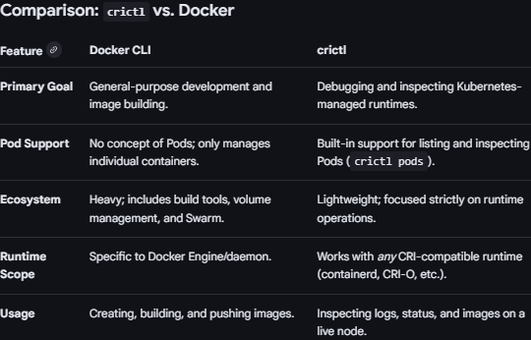
  - Used crictl for container runtime management analogous to Docker CLI. crictl is the standard tool for managing container runtimes in Kubernetes because it is built specifically to interact with the Container Runtime Interface (CRI). Kubernetes moved away from docker as a direct runtime in version 1.24 (removing the "dockershim") to favor more lightweight, CRI-compliant runtimes like containerd.

Kubernetes Ports and Their Purpose
Port(s) | Purpose | Accessible From
6443 | Kubernetes API Server | Within VPC
10250 | Kubelet API | Both Master & Worker
10256 | Kube Proxy | Worker nodes only
10259 | Scheduler (internal control plane) | Internal only
2379-2380 | etcd client and server ports | Internal only
22 | SSH Access for admin | Admin IP only
30000-32767 | NodePort services (external access) | Worker nodes

Core Utilities and Tools Installed
Utility | Role | Version Used in Video
kubeadm | Cluster bootstrap and administration tool | 1.30
kubelet | Node agent managing pods and containers | 1.30
kubectl | CLI client to interact with Kubernetes API | 1.30
containerd | Container runtime engine (default since v1.24) | 1.7.4
runc | Low-level container runtime | Latest (version not specified)
CNI Plugins | Network plugins for pod networking (Calico, Cilium) | Latest (Calico applied)

Key Insights
- Using kubeadm simplifies cluster setup by automating control plane component installation and configuration.
- Pod network CIDR alignment between kubeadm and CNI plugin is critical; mismatches cause network pod failures.
- Security groups/firewall rules must be carefully configured to allow necessary communication between control plane and worker nodes.
- Access to nodes via SSH is essential for setup and troubleshooting, even if not explicitly documented in official Kubernetes port lists.
- Cluster nodes must share the same Kubernetes version for compatibility.
- Resetting the cluster with kubeadm reset allows clean troubleshooting and reconfiguration without rebuilding VMs.

